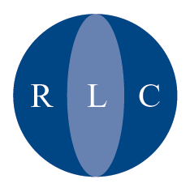

The Refugee Legal Centre is an independent charity offering free legal advice and representation to asylum seekers and refugees.
Registered as Refugee Legal Centre Registered Charity No 1012804. OISC No. N200100009. VAT Registration No 672 0317 56. Registered in England: No 2710867
Registered Address: 153-157 Commercial Road, London E1 2DA.

PRESS RELEASE
4th August 2005

Removals to Zimbabwe

The High Court has today found there is an arguable case that failed asylum seekers are at risk of being persecuted in Zimbabwe for claiming asylum in the UK. Proceedings have been stayed so that the specialist court, the Asylum and Immigration Appeals Tribunal, can consider the issue in a test case.

Barry Stoyle, Chief Executive of the Refugee Legal Centre, said:

““We are very concerned at the dangers faced by asylum seekers who are returned to Zimbabwe. We are pleased that the Court has agreed there is an arguable case that they face persecution. We look forward to being able to argue the matter in full before the Asylum and Immigration Tribunal.”

“We are concerned that some Zimbabwean asylum seekers are still detained. It is now only proper for the Home Office to release all detained Zimbabwean detainees pending the outcome of the test cases.”

We have no further comment to make pending the outcome of the test case.

End

