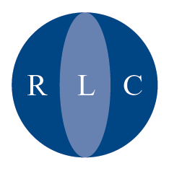

Refugee Legal Centre
Nelson House
153-157 Commercial Road
London E1 2DA

The Refugee Legal Centre is an independent charity offering free legal advice and representation to asylum seekers and refugees.
Registered as Refugee Legal Centre Registered Charity No 1012804. OISC No. N200100009. VAT Registration No 672 0317 56. Registered in England: No 2710867
Registered Address: 153-157 Commercial Road, London E1 2DA.

PRESS RELEASE
14th July 2005

Suspension of the Removal of Asylum Seekers to Zimbabwe

We are very pleased to confirm that, following an application to the High Court, the Home Office has agreed to suspend all removals to Zimbabwe pending the outcome of a hearing of two test cases on 4th August. There is a mounting body of evidence to suggest that failed asylum seekers are in danger of being persecuted in Zimbabwe for claiming asylum in the UK. We will be relying on this evidence at the hearing of 4th August.

Barry Stoyle, Chief Executive of the RLC, said:

“We are very concerned at the dangers faced by asylum seekers who are returned to Zimbabwe. Of particular concern is the fact that many Zimbabwean asylum seekers are detained in the UK and do not have legal representation. Unrepresented asylum seekers were particularly vulnerable to removal before the outcome of the test cases. We are delighted that the Home Office has agreed to suspend all removals to Zimbabwe. It is now only proper for the Home Office to release all detained Zimbabwean detainees pending the outcome of the test cases.”

We have no further comment to make pending the outcome of the test cases.

End

