27 August 2003

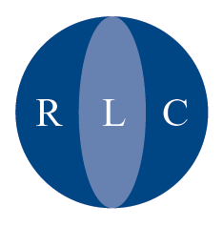

Refugee Legal Centre
Nelson House
153-157 Commercial Road
London E1 2DA

Direct Line
020 7780 3227
Switchboard
020 7780 3200
Facsimile
020 7780 3201

Please Telephone
Between 10:00 am
and 4:00 pm

Mr Muhammud Islam
Department of Constitutional Affairs
Public Legal Services Division
3rd Floor
Selbourne House
54 Victoria Street
London SW1E 6QW

Dear Mr Islam

Please find attached the Refugee Legal Centre’s response to the consultation on the changes to publicly funded immigration and asylum work.

In particular I would draw your attention to the joint counsel’s opinion in Appendix 2 of our response to the effect that unless the DCA/LSC are able to produce (and disclose to consultees for comment) a clear and cogent case having a proper evidential basis, the proposed maximum time limits for advice could not lawfully be adopted.

I also attach the Refugee Legal Centre’s response to the LSC’s consultation on the draft not-for-profit immigration specification.

We would appreciate acknowledgement of your receipt of our response.

Yours faithfully

Deri Hughes-Roberts
Regional Manager

OISC No. N2001000009

The Refugee Legal Centre is an independent charity offering free legal advice and representation to asylum seekers and refugees.
Registered as Refugee Legal Centre Registered Charity No 1012804 VAT. Registration No 672 0317 56. Registered Address: 153-157 Commercial Road, London E1 2DA

